

THE UNIVERSITY OF THE WEST INDIES

ASSIGNMENT 2
SEMESTER I, 2025/2026

Code and Name of Course: COMP2201 – Discrete Mathematics

Assignment 2 - Group Assignment
AREA | DESCRIPTION
Objectives | To have students apply the knowledge garnered during weeks 4 to 9  To have students work within a group setting with the allocation of work but still ensuring that the knowledge is spread throughout the group
Title | Assignment 2 – Group Assignment
Deliverable | The answers in written and video for the questions which follow the instruction pages.  A summary of the contribution made by each student in the group.
Instructions | 1. Review Lectures of weeks 4 to 9 of the course, the COMP2201 Text and any other related Discrete Mathematics material  2. Read the Assignment 2 Sheet thoroughly  3. Submit the (written and video) gradable solution by using the  COMP2201 Assignment 2 - Group located within the ASSIGNMENTS Section of the VLE COMP2201 Course Environment. This may also be accessed by choosing the Assignments section below “Activities”
Format | The written solution for this assignment must be submitted as a Microsoft Word document.  - Your ID numbers should form part of the Microsoft Word file name. The file name should take the format “COMP2201 Assignment 2 Semester 1 2025-2026 XXXXXXXX YYYYYYYY ZZZZZZZZ” where XXXXXXXX, etc. represents the student ID numbers.  The video explanation for the student-selected solutions for this assignment may be of any known video format.  - Your ID number should form part of the Video file name. The file name should take the format “COMP2201 XXXXXXXX” where XXXXXXXX represents the student ID number.
Upload Constraint | The written solution and video explanation for this assignment should be uploaded in the relevant space provided in VLE (See “Instructions” section above). A message indicating “File uploaded successfully” will acknowledge that the file has been sent successfully.  Do NOT assume your project has been received if you do not get this acknowledgement.
Group Restrictions | This is a group assignment.  Each group must have a minimum of 2 members and a maximum of three (3) members.
Late Assignments | Late assignments are accepted. These are however graded then 25% deducted for each day of late submission.
Expectation | It is expected that students will discuss means to a solution within their group. The actual work written is expected to reflect the group’s decision. Where replication of work is identified between groups, each paper will be graded. The allocated grade to each group’s piece of work for where this anomaly is identified will be the grade divided by the number of replications discovered.
Scoring Rubric | Your electronic submission will be evaluated on:  - Your attempt of all questions  - A video submission (including camera view) with your explaining your solutions for any three questions in Section B (questions 11 – 15)  - The written response submitted for all questions (See detail individual marks below)  – 95 marks  - Group Dynamics i.e. for accomplishing the task as a group  – 5 marks.  Marks allocated based on correct inclusion of each student id number and name and a brief description as to the contribution made within the group.  The actual grade of 100 marks will be displayed. The actual grade allocated is the percentage of the maximum marks (8 points)
Due Date | Sunday, November 30, 2025
S E C T I O N A (55 marks)
DO ALL TEN (10) QUESTIONS
NO VIDEO SUBMISSION REQUIRED

Question 1 [6 marks]
Consider the recurrence function

$$f(n)=59049f\left(\frac{n}{9}\right)+3^{n}\log^{2}{n}$$

Give an expression for the runtime f(n) if the recurrence can be solved with the
Master Theorem. Assume that f(n) = 1 for n ≤ 1. [6]

Question 2 [5 marks]
Let f_{i}(n), g_{i}(n) and h_{i}(n) be functions defined f_{i} , g_{i} , h_{i}: Z⁺ → Z⁺
where Z⁺ is the set of Positive integers
Determine the truth of the following statement
$$If$$
$$f_{1}\left(n\right)=Θ\left(f_{2}\left(n\right)\right)\text{ , }g_{1}\left(n\right)=Θ\left(g_{2}\left(n\right)\right),\text{ and }h_{1}\left(n\right)=Θ\left(h_{2}\left(n\right)\right)$$
$$\text{then}$$
$\left(h_{1}\right)\left(n\right)+ \left(g_{1}h_{1}\right)\left(n\right) + \left({f_{1}g}_{1}h_{1}\right)\left(n\right) = Θ\left(\left(f_{2}g_{2}h_{2}\right)\left(n\right)\right)$
$$\text{may be written as }$$
$h_{1}\left(n\right) + g_{1}\left(h_{1}\left(n\right)\right) + f_{1}\left(g_{1}\left(h_{1}\left(n\right)\right)\right) = Θ\left(f_{2}\left(g_{2}\left(h_{2}\left(n\right)\right)\right)\right)$ [5]

Question 3 [5 marks]
In a geometric series, the sum of the fifth term and the ninth term is $349\frac{29153}{85293}$.
Three consecutive terms of the same series are $\frac{117649}{217971}x$, 1$\frac{169630}{653913}x$ and $2\frac{1841323}{1961739}x$.
x is equal to $1\frac{100322}{117649}$ of the seventh term in the series, and the sum of the terms in the
series is $11\frac{5866663}{5885217}x$.
- Find n, the number of terms in the series. [4]
- Using a Large Language Model (LLM) (such as ChatGPT, Gemini, Claude, etc.), determine the Limit of the series where the first term a is increased by
$\frac{21}{13}$ and the common ratio r, is decreased by 2. [1]

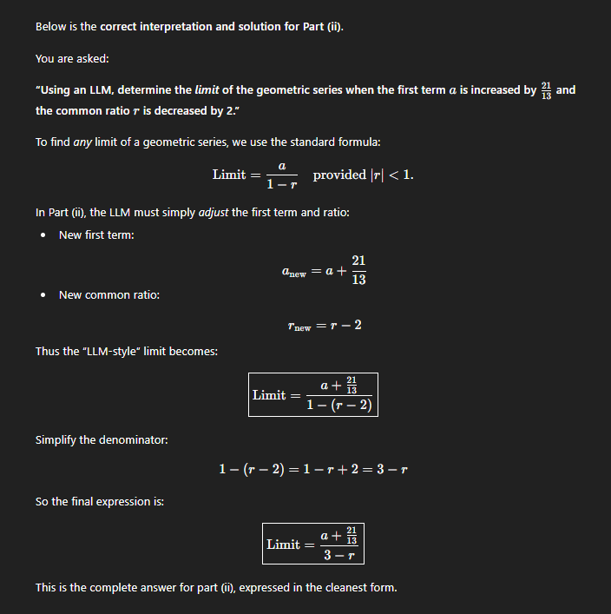

Question 6 [7 marks]
Let f(n) be defined by
$$T(1)=49 \\ T(n)=16807T\left(\frac{n}{7}\right)+243n^{5}\log_{7}{n}$$
if n > 1 and n = 7^{k}, where k is a positive integer.

i. By using the principles of Recurrence Relation, find a general formula
for T(n) [4]
ii. Hence show that $T(n)=Θ\left(n^{5}{\log_{7}}^{2}n\right)$. [3]

Question 8 [7 marks]
There are 270 students registered to the course COMP2201 in 2024-2025 Semester 1 at The University of the West Indies, Mona. However, the Pigeonhole Principle suggests that only where there are 367 students (similar to COMP1127) in the course, at least two people must share the same birthday.
- Show that the number of people randomly chosen is significantly less than that
suggested by the Pigeonhole Principle. [3]
- Using the methodology derived in section i. of this question, illustrate how you would find the smallest number of students to be chosen at random from the batch of COMP2201 students so that the probability that at least two of them
share the same birthday, is in excess of 99.99%. State any assumptions made towards the solution. [3]
- Using a Large Language Model (LLM) (such as ChatGPT, Gemini, Claude, etc.), provide a solution for section ii and describe the differences in the two
answers. [1]

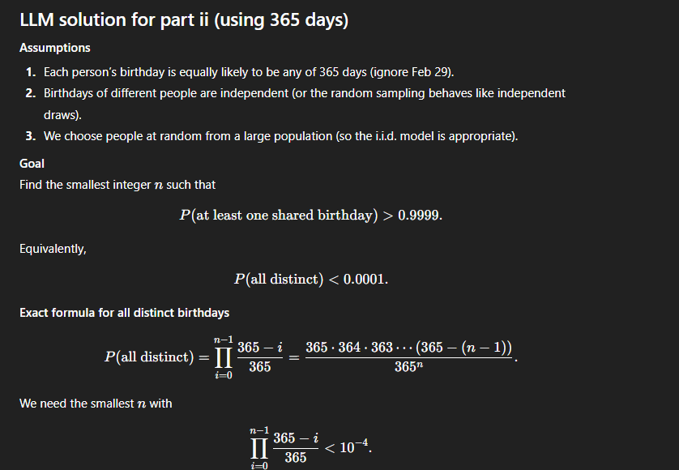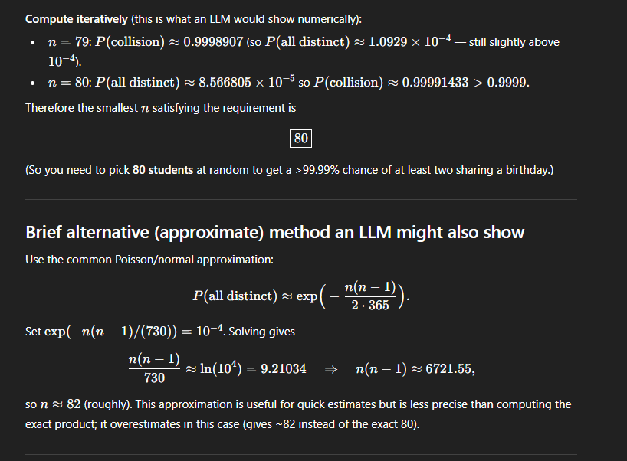

Differences:
• The method in part (ii) used the exact product formula and obtained $n=80$.
• The LLM-style approach, which used an exponential/Poisson approximation, produced $n≈79$.

Question 11 [7 marks]
Given the following recurrence relation
s₀ = 1
s₁ = 6
s_{n} = 4s_{n-1} + 45s_{n-2} for n ≥ 2 [5]

i. Find a closed form expression for the following recurrence relation
ii. Using a Large Language Model (LLM) (such as ChatGPT, Gemini, Claude, etc.), provide a detailed solution for section i and describe the differences in
the two solution approaches, solutions, and answers. [2]
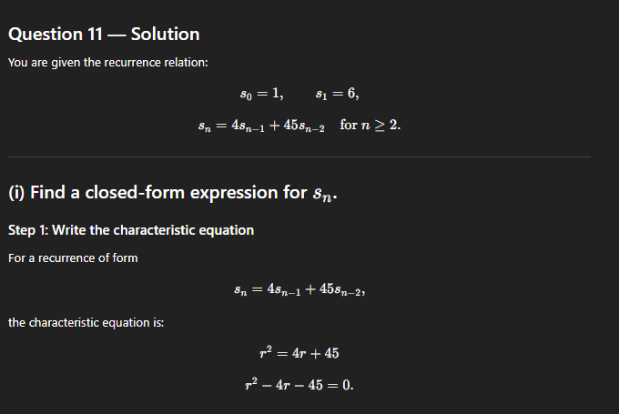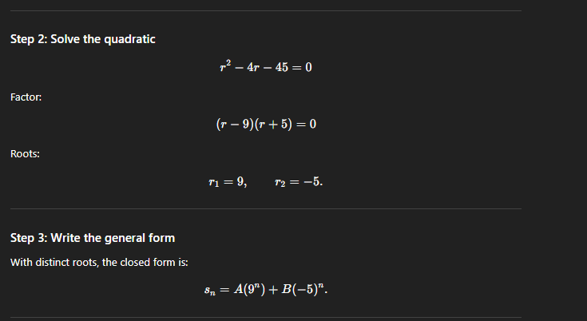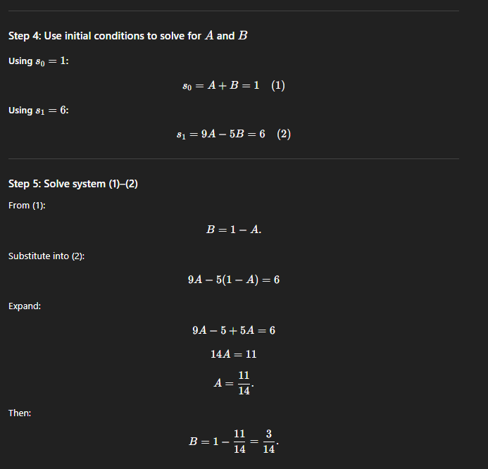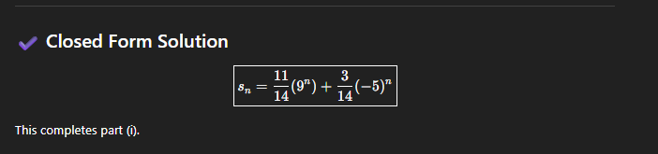

The LLM (ChatGPT) takes a different approach by using the characteristic equation derived from $s_{n}=4s_{n-1}+45s_{n-2}$, forming $r^{2}-4r-45=0$and applying the quadratic formula to obtain the roots $9$and $-5$, which leads to the general solution $s_{n}=A 9^{n}+B(-5)^{n}$.
Using the initial conditions $s_{0}=1$and $s_{1}=6$, it forms the simultaneous equations $A+B=1$and $9A-5B=6$, solves for $A$and $B$, and arrives at the same closed-form expression for the recurrence relation, $\frac{3}{14}(-5)^{n}+\frac{11}{14}9^{n}$.

Question 15 [10 marks]
Given the following concerning an arithmetic series and a geometric series:

- The third term of the geometric series is the same as the ninth term of the arithmetic series. Additionally, the negation of the fourth term of the arithmetic series less $\frac{11}{4}$ is equal to the second term of the geometric series less the first term of the said geometric series$.$

- The sixth term of the arithmetic series less the eighth term of the said series exceeds the sum of the first two terms of the geometric series by $\frac{1}{2}$. Furthermore, the sum of the first three terms of the arithmetic series is three times the second term in the said series. The second term of the geometric series is four times that of the common ratio of that series.

- The sum of the first three terms of the arithmetic series, S_{AP-3} and the sum of the first three terms of the geometric series, S_{GP-3} are related by the formula
4S_{AP-3} – 3S_{GP-3} – 12 = 0

What is the total of the sum of the first four terms of the geometric series and the
sum of the first thirteen terms of the arithmetic series? [10]

